**Deep Learning Project on Crop Disease Detection.**

**Name:** Pakalapati Sri Raam Tej

**Reg.no:** 200968170

**Section**: B(Batch4)

**Problem Statement:**

Crop diseases are a major threat to food security, but their rapid identification remains difficult in many parts of the world due to the lack of the necessary infrastructure.

Automatic detection of plant diseases is an essential research topic as it may prove benefits in monitoring large fields of crops, and thus automatically detect the symptoms of diseases as soon as they appear on plant leaves**.**

**Discription of the Data ( Meta Data):**

This dataset is available as augmented dataset from the original dataset https://data.mendeley.com/datasets/tywbtsjrjv/1. This dataset consists of about 87K rgb images of healthy and diseased crop leaves which is categorized into 38 different classes. The total dataset is divided into 80/20 ratio of training and validation set preserving the directory structure.

Note: This description is given in the dataset itself

* Total disease classes in the dataset are: 38 .
* Number of unique plants in the dataset are: 14 .
* There are 70295 images for training in the dataset.
* There are 17572 images for validation.

Pre-Processing:

This dataset is already augumented and has 87k images so data augumentation is not required.

Not much pre processing is required for the dataset.

I used image data generator for making train generator and validation generator since the data set is large this helps for easy computation.

Normalization

Train ,validation split.

**Project Objective**:

Overall, the approach of training deep learning models on increasingly large and publicly available image datasets presents a clear path toward smartphone-assisted crop disease diagnosis on a massive global scale

This approach represents a viable additional method to help prevent yield loss.

This model strives for the betterment of the society.

**Phase2:**

|  |  |  |  |  |
| --- | --- | --- | --- | --- |
| TITLE | MODEL | mAP | AUTHOR | YEAR |
| Detection of PlantDiseases | Inceptionv3 | 98.3 | [Mikol Prof. A. R. Bhagat Patil1](https://paperswithcode.com/author/mikolaj-wieczorek)  [, Lokesh Sharma2](https://paperswithcode.com/author/mikolaj-wieczorek)  [, Nishant Aochar3](https://paperswithcode.com/author/mikolaj-wieczorek)  [, Rajat Gaidhane4](https://paperswithcode.com/author/mikolaj-wieczorek)  [,](https://paperswithcode.com/author/mikolaj-wieczorek)  [Vikas Sawarkar5](https://paperswithcode.com/author/mikolaj-wieczorek)  [, Dr Punit Fulzele6](https://paperswithcode.com/author/mikolaj-wieczorek)  [, Dr. Gaurav Mishra](https://paperswithcode.com/author/mikolaj-wieczorek) | 2020 |
| Deep learning for Image-Based Plant detection | CNN model | 99.35% | Prasanna Mohanty | 2021 |
| Detection and Classification of leaf disease usingArtificial Neural Network | Artificial Neural Network (ANN) | 80%. | Malvika Ranjan | 8 Dec 2018 |
| Detecting Jute Plant Disease Using Image Processing and Machine Learning | Multi SVM classifier | 86% | Zarreen Naowal Reza  ,etc | September 2016 |
| Recent Machine Learning Based Approaches for Disease Detection and Classification of Agricultural products. | K-means, GLCM, ANN, SURF, CCM, SVM | 95% | Mukesh Kumar Tripathi,…… | August 2016 |
| Detection of leaf disease and classification using digital image processing | GLCM, SVM, K-means | 90% | R. Meena Prakash | March 2017 |

Literature Review:

**Models:**

* Alex-Net
* MobileNet
* Vgg-16
* InceptionV3

**PROPOSED METHOD:**

* Data Classification
* Building the models
* Training
* Testing

**DATA CLASSIFICATION:**

Selection of proper set of images for training of model is a significant task.

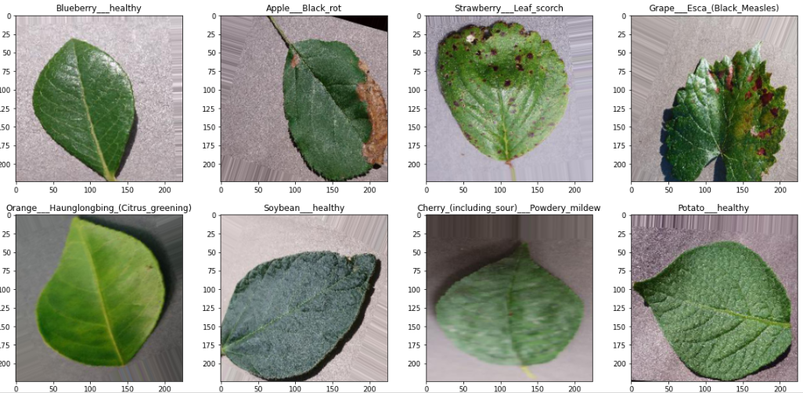

This dataset is recreated using offline augmentation from the original dataset. The original dataset can be found on [this](https://github.com/spMohanty/PlantVillage-Dataset) github repo. This dataset consists of about 87K rgb images of healthy and diseased crop leaves which is categorized into 38 different classes. The total dataset is divided into 80/20 ratio of training and validation set preserving the directory structure. A new directory containing 33 test images is created later for prediction purpose.

**Building the models:**

1)ALEX-NET:

Architecture:

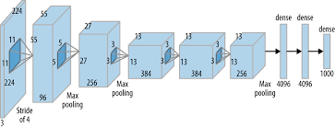

2)VGG-16Architecture:

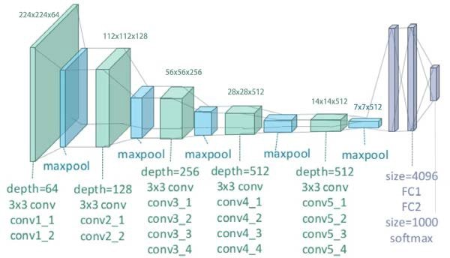

3)Mobile Net:

Architecture:

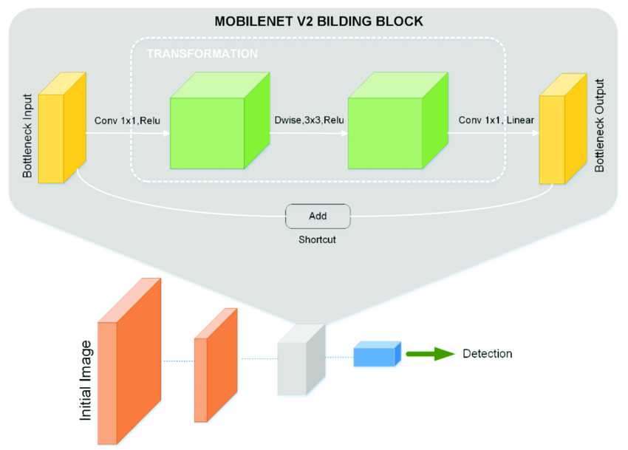

4)Inception Model:

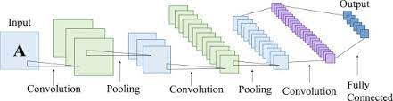

Training:

The model is trained for 100 epochs in each model using early stopping to check if change in val_loss is very very less to stop.

1)ALEX-NET

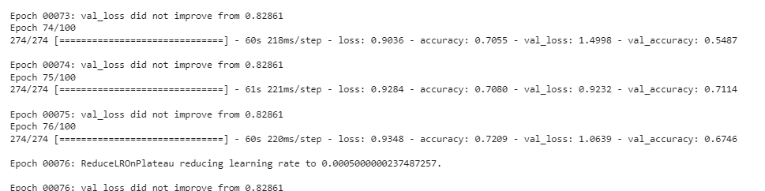

2) VGG-16

3)MOBILE NET:

4)INCEPTION MODULE:

**TESTING:**

1)ALEX-NET:

We trained the model with this architecture and the test accuracy is around 0.72 and test loss around 0.86 which are not ideal for the requirement.



2)VGG-16

We trained the model with this architecture and the test accuracy is around 0.898 and test loss around 0.3088 which can be used for the prediction unless a better model exist.



3)MOBILE NET

We trained the model with this architecture and the test accuracy is around 0.88 and test loss around 0.396 which can be used for the prediction but Vgg-16 has the better performance than this.



4)INCEPTION MODULE:

We trained the model with this architecture and the test accuracy is around 0.91 and test loss around 0.21 which can be used for the prediction and has the better performance than remaining models



Model Selection:

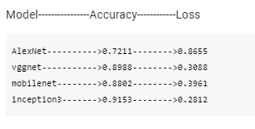

By seeing the accuracies and loss we can say inception model is the best performing model.